# CRM Environment Setup Guide

## Section 1. Applications Required

There are 3 main applications that we use for the environment

* **Nodejs** – NodeJS is a variation of javascript that has 2 main advantages. First, you can run the website server directly from the NodeJS application. Secondly, you can download opensource packages that allows you to leverage features that other people have already built (such as login pages, stylings, etc.)
  + **Link to Download**:<https://nodejs.org/en/>
* **MongoDB** – MongoDB will be our database. MongoDB also has a built in local hosting to make the DB available to your local network.
  + **Link to Download**: <https://www.mongodb.com/download-center/community>
  + **Optional:** MongoDB can only be run by default. So it is recommended that you also download a MongoDB user interface. I use the stock [MongoDB Compass](https://www.mongodb.com/products/compass), although [NoSQLBooster](https://nosqlbooster.com/downloads) and [Studio 3T](https://studio3t.com/?utm_source=Guru99&utm_medium=listing&utm_campaign=leadgen) is also very popular
* **Github** – This is used as our main repository (code and other data such as test data sets, minutes, etc.) There are many ways to get access to the code repository, but my favorite gitjhub UI is Sourcetree by Atlassian. Github also has their own UI if you want to go for that.
  + **Link to Download (Sourcetree):** <https://www.sourcetreeapp.com/>
  + **Link to Download (Github Stock UI):** <https://desktop.github.com/>

Next you’ll need to download a text editor. For basic editors, Notepad++ and SublimeText is good. There’s lots of fancier applications out there with a lot more features (read: complexity) if you’re interested. I’ll leave this up to personal preference.

Project Management wise, we use the following:

Communication: **Slack** (chanseyworkspace.slack.com)

Task Board: **Asana** (<https://app.asana.com/0/1119316470480196/>)

Video Conferencing: **Google** **Meet** (Refer to calendar Invite)

## Section 2. Configure Applications

I realize that I’ve recommended a few solutions for each, so for simplicity’s sake, I will walk through the installation for only 1 of the application choices. Lots of information will still be similar for other applications and should be easy enough to follow. Please install these in the correct order below (i.e. git first, then MongoDB then node) to make sure you don’t get any errors.

**Gitbhub/Sourcetree Installation**

1. Signup for a github account (<https://github.com/join?source=header-home>)
2. Once signup is complete, let one of the Github admins know what your username is and we can add you to the repository.
3. Install Sourcetree (link above)
4. Open sourcetree and sign into your new github account.
   1. Note: If you are having issues connecting or retrieving data, make sure your authentication is set to OAuth, and Protocal is HTTPS. This can be changed under Tools -> Options -> Accounts -> [Select your github account]

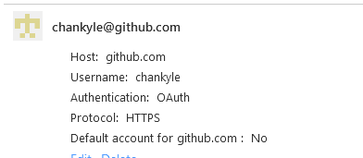

1. Once you have access to the CRM Repository (step 2), add a new remote repository by clicking the + sign on the top of the screen, then clicking remote.

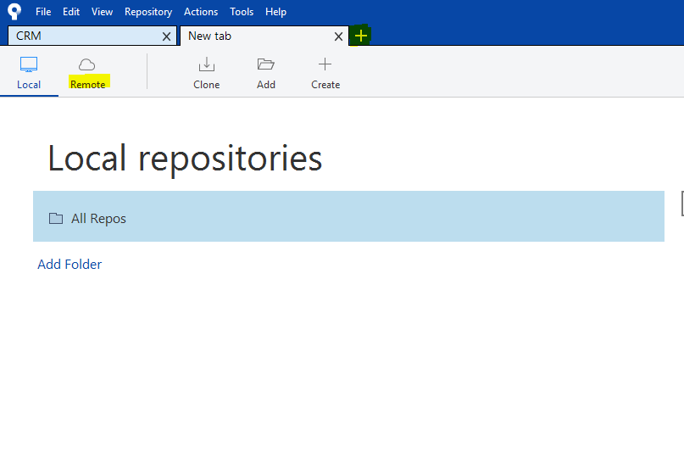

1. A selection of repositories will show up on the right hand side. Select the CRM repository and click “Clone.
2. Under the Clone screen, you will see 4 fields which are set up in the following order:
   1. **Github repository location** - Do not change this. This should be set to https://github.com/[username]/CRM
   2. **Local Folder Location** – Select an easily accessible location where you want to save the website’s code base
   3. **Name of the Application** – You can set a custom name for the local files in case you want to call the project something else.
   4. **Local Folder** ­– Leave this as [Root]
3. Once the progress bar completes, you should have the entire code base available to you. To test that you have the correct code base, check one of 2 things.
   1. Under the “Branches” section non the left side bar, click master and look at the first line item, and make sure that the date matches the last updated date on the github website.

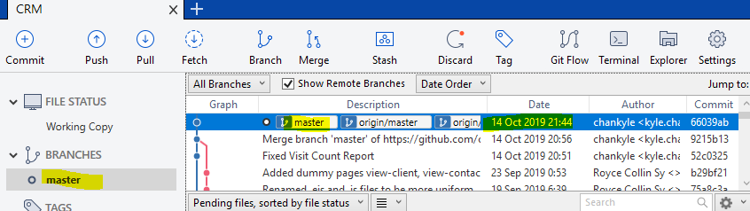

* 1. Check the local repository you saved the code base to (see step 7b) and make sure that there are files that exist

**MongoDB / MongoDB Compass**

1. I actually recommend [this blog post](https://closebrace.com/tutorials/2017-03-02/the-dead-simple-step-by-step-guide-for-front-end-developers-to-getting-up-and-running-with-nodejs-express-and-mongodb) to initially set up mongoDB since it goes through both Mac and Windows installs. Go to “Part 3 – Create our DB and read stuff from it” and follow steps 1 to 3.
   1. Note: In step 3, instead of creating a database called “nodetest1” it is important that you call the database “CRM” since that is currently what the application is set to look for.
2. Navigate to the location where you installed mongoDB and run the mongod.exe file which can be found in MongoDB\Server\[version]\bin.
   1. You can either run this through the command prompt by navigating to the folder and typing “mongod” (PC) or “./Mongod” (Mac) without the brackets. Or you can navigate to the folder via Explorer/Finder then run mongod.exe.
3. You should know that the database server is running when you see “Waiting for connections on port 27017”



1. Install MongoDB Compass (or any other MongoDB UI) and connect to the database with the following information
   1. Sever: Localhost
   2. Port: 27017

**NodeJS**

1. Install NodeJS anywhere on your pc. (“C:/ProgramFiles” is a good choice)
2. Open a command prompt window
3. Navigate to the location where you had saved the code repository (See step 7b above)
   1. Refer to appendix below for helpful command line tips
4. Then go into the CRM folder within the repository.
   1. You’ll know you’re in the right place when you type “dir” and you see the following files and folders (or at least something similar)

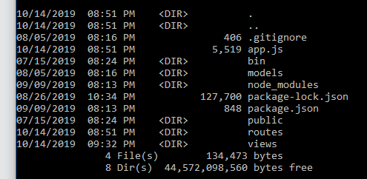

1. On your first install, enter “npm install” in the command prompt. This should install all the packages (AKA open source libraries) that the application requires.
   1. It is also a good idea to update the packages once in a while to make sure you have the most updated libraries and in case there are any vulnerabilities found in prior libraries. This can be done using “npm update”
2. Once the packages are installed, type “npm start” to run the application.

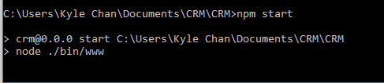

1. The application should now be running and reachable by opening your browser and navigating to “localhost:3000”
2. To be able to log into the application, you’ll need to first register an account.
   1. For development purposes I recommend a very simple log in since you’ll need to log in a lot.
3. Once the account is created, login to the application by going to localhost:3000/login
4. Ensure that you’ve reached the home page of the application, then go into the MongoDB UI to make sure that the CRM database has been created with a table called “accounts” with 1 new account. Ensure that the password is not readable and properly hashed.

## Appendix

How to navigate Command Prompt (Windows) or Terminal (Mac OSX)

To keep this simple, I’ve included both windows and mac versions of certain commands.

* To open Command Prompt (windows) quickly, type Win+R to open “run as” window, and type “cmd”.
* To open terminal (Mac) quickly, use the Apple+Space shortcut to open finder, and type terminal
* **>** : When first opening CMD, the > sign is the break which separates the current folder location (shown on the left of the >) and the current command you are typing (shown on the right of the >). In the example below, I am in the Documents folder in my computer, with the current command I am typing in “mkdir test”  
  
* **dir (windows), ls (mac)**: To list all files and folders in the current directory, type **dir/ls**. The example below lists all files and folders in my Documents folder.

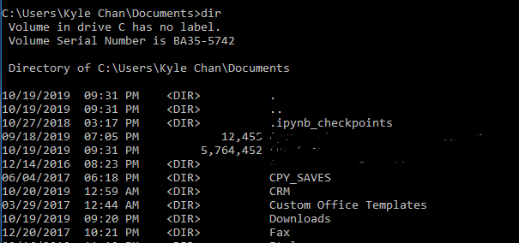

* **cd:** To change directory, type cd XXXX where XXXX is the name of the folder. In the example below, I am changing path into the CRM folder.



* **Tab**: To autofill the folder name, you can press tab. The entry will be autofilled with the first matching entry alphabetically. In the example below, pressing tab will auto populate “Program Files”. Pressing tab a second time will auto populate “Program Files (x86)”

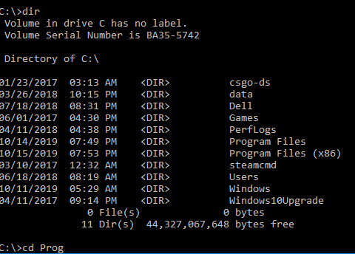

* **/**: When using the cd function to change directory, you can type a folder path by using / to signify a folder. You can also use tab to auto fill the selection and it will handle it quite well. In the example below, I only typed the first couple of letters for each sequential folder and used tab.

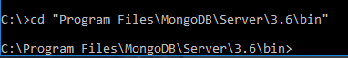

* **cd ..** : To go back to move up 1 folder. Note you can also use “cd ../..” to move up 2 folders



* **ctrl + c:** Press Control + C to terminate any actions. This can be used to terminate the node application and restart the app by typing “npm start” again. This saves you time by having to navigate back into the application.
* **Mkdir XXXX:** Create a folder with the name XXXX
* **Sudo [command] (Mac Only):** To run a command in super user mode.
  + To run super user commands in Windows, you need to run command prompt as administrator (right click command prompt)
* To run apps in windows, just type the name of the .exe file you are trying to run



* To run apps in Max, type in ./ before the name of the application or open [file]

